R/Shiny is an R package that makes it easy to build interactive dashboards that look great in R. Additionally, we can build Machine Learning or AI pipelines behind the screen to integrate data science technologies. Apps built with shiny can have reactive elements that change according to user inputs – a powerful feature unique to the Shiny ecosystem. And shiny Apps can be custom styled according to the needs of the user. All-in-all, Shiny Dashboards are an excellent tool for telling data-centric stories in professional, enterprise-level applications.

1. Why Shiny
2. 5 Great Shiny Dashboards
3. Shiny Fluent
4. Port Analytics
5. Visualise
6. Shiny Enterprise App
7. Damage Assessment
8. Conclusion

# Why Shiny

So why should you use R Shiny Dashboards?:

**Reactivity** – Various plots, graphs, tables, and even inputs can be coded to react to user inputs. This is integrated into the Shiny logic and does not require manual coding.

**Time** – You can rapidly develop a PoC faster with Shiny than with other dashboard building tools. An advanced dashboard can be ready in one month from the first rough sketch of the app.

**Styling** – Any custom design can be implemented on Shiny with CSS. Even Microsoft’s Fluent UI can be implemented.

**JS** – For advanced usage and functionality, JavaScript is also supported.

**R** – Shiny is based on R which means the dashboard can have all of R’s statistical and machine learning capabilities.

“It took us one month to get from sketch to a working application” **John Dannberg, The Boston Consulting Group**

# 5 Great Shiny Dashboards

Let’s look at 5 unique dashboards built with R Shiny. The apps below are great examples of how Shiny integrates data science, large data sources, javascript, CSS, and R to deliver superior results over similar solutions available on the market. These dashboards demonstrate that Shiny apps can improve user experience by merging the complexities of large data and data science- related technologies built into one stand-alone application.

## Shiny Fluent App

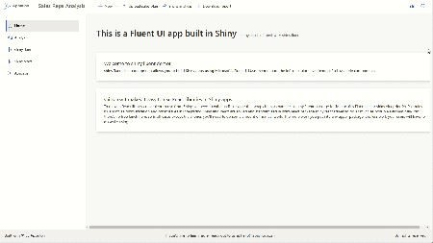

This Shiny dashboard is built using the newly launched shiny.fluent and shiny.react packages. This dashboard shines on looks and feel. It takes inspiration from Microsoft’s Fluent library and represents a breakthrough in Shiny UI. The Shiny Fluent App has all the components for demonstration purposes, including interesting features like the “People Selector” (try it out here). This allows the user to select from a list of people with a photo beside their names. There are other cool components like progress indicators and modals. For enterprises already using MS products, the Shiny Fluent App brings a professional look and elegant design that is familiar for their users.

Shiny Fluent Dashboard Live!

## Port Analytics

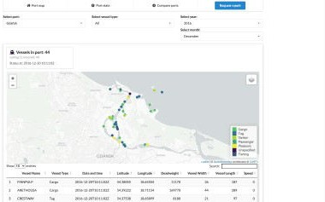

The Port Analytics dashboard shows an overview of port logistics to assist Shipping Port/Dock managers – the ships in these ports, the number of vessels in a port over time, and a comparison between ports and other analytics with plots, charts, and maps. In this case, Shiny is used to present a sleek, functional dashboard design while having advanced analytics embedded within the dashboard. To showcase data in a geospatial format, we used leaflet – the gold standard in maps as it supports multiple map styles and treats objects within the map as layers. The dashboard also shows a data table based on the user selection. This is where reactivity in shiny plays a powerful role in user interaction and inputs.

Port Analytics Live!

## Visualise

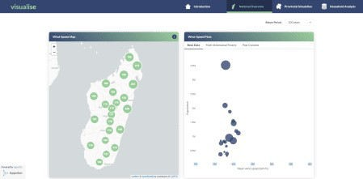

Shiny dashboards can also be built to do good in the world and improve human life. This dashboard visualizes disaster risk and development indicators in Madagascar. The Visualise dashboard combines spatially explicit hazard modeling with nationwide household survey data. Users can quickly visualize vulnerable communities with consistent analysis of cyclone risk at the national, provincial, and household levels. This dashboard has a consistent style and color scheme that lends a unique look and feel. It has three modules namely National Overview, Provincial Simulation, and Poverty and Equity Analysis. Feel free to click through the dashboard to know more.

Visualise Live!

## Shiny Enterprise App

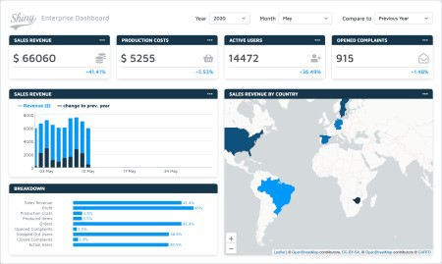

A simplistic, yet highly informative dashboard that demonstrates how quickly a dashboard can be built and with ease. Near the top, we have business metrics like Revenue, Costs, Active Users, and Complaints. Along the left side, a column chart shows the revenue over time and with additional selectable metrics. On the right side, a color-coded leaflet map presents revenue per country. Near the bottom, we have the breakdown of each metric. Users can change the time frame to view temporal changes for metrics in the plots and maps.

Shiny Enterprise Dashboard Live!

## Damage Assessment

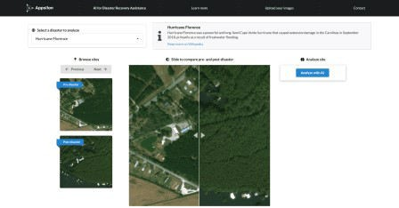

Here we present an example of how a Shiny Dashboard can combine powerful data analytics with AI to be used for good. The Building Damage Assessment app identifies impacted structures in areas struck by natural disasters with the use of satellite imagery and AI. The users can interact with the dashboard by moving a slider across the two images. This clever tool provides a creative way for users to engage with the story behind the data. Users can analyze the imagery with an AI by selecting the “Analyze with AI” button. The AI takes the images as input and highlights the buildings in red, orange, yellow, and green colors to indicate 4 levels of damage: destroyed, majorly damaged, minor damage, and no damage, respectively.

Damage Assessment Live!

# Conclusion

This is not an exhaustive list and there are many other beautiful and seemingly complex dashboards out there. Open source Shiny, having easy-to-use tools for full-stack development, fast prototyping, and a wealth of integrated packages for visualization, is a must-use for projects requiring R’s data-handling capabilities and user-friendly optimization. As the examples above show, shiny allows for unique storytelling experiences by creating interactive and visually appealing platforms to showcase your data. These dashboards are truly versatile, catering to a wide variety of problems and set of needs.